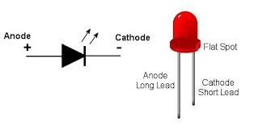

***Active-Low LED connection***

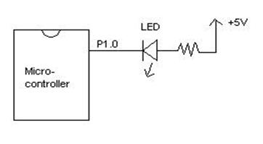CLR P1.0

SETB P1.0

Logic 0 🡪 ON active low LED

Logic 1 🡪 OFF active low LED

